**DIAGRAMA**

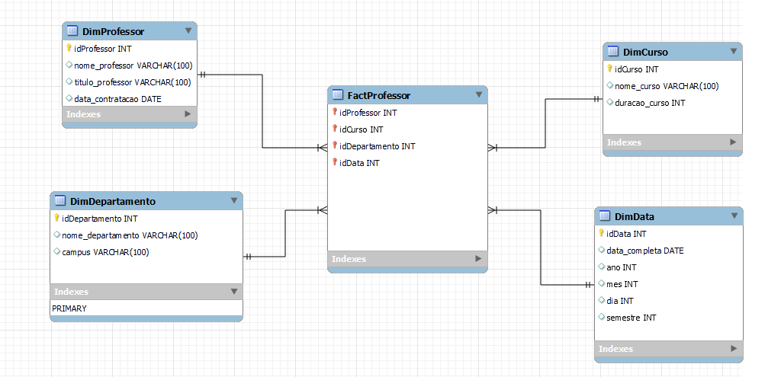

**CONSULTA SQL**

CREATE TABLE IF NOT EXISTS `mydb`.`DimProfessor` (

`idProfessor` INT NULL DEFAULT NULL,

`nome_professor` VARCHAR(100) NULL DEFAULT NULL,

`titulo_professor` VARCHAR(100) NULL DEFAULT NULL,

`data_contratacao` DATE NULL DEFAULT NULL,

PRIMARY KEY (`idProfessor`))

_________________________________________________________________

CREATE TABLE IF NOT EXISTS `mydb`.`DimDepartamento` (

`idDepartamento` INT NULL DEFAULT NULL,

`nome_departamento` VARCHAR(100) NULL DEFAULT NULL,

`campus` VARCHAR(100) NULL DEFAULT NULL,

PRIMARY KEY (`idDepartamento`))

_________________________________________________________________

CREATE TABLE IF NOT EXISTS `mydb`.`DimCurso` (

`idCurso` INT NULL DEFAULT NULL,

`nome_curso` VARCHAR(100) NULL DEFAULT NULL,

`duracao_curso` INT NULL DEFAULT NULL,

PRIMARY KEY (`idCurso`))

_________________________________________________________________

CREATE TABLE IF NOT EXISTS `mydb`.`DimData` (

`idData` INT NULL DEFAULT NULL,

`data_completa` DATE NULL DEFAULT NULL,

`ano` INT NULL DEFAULT NULL,

`mes` INT NULL DEFAULT NULL,

`dia` INT NULL DEFAULT NULL,

`semestre` INT NULL DEFAULT NULL,

PRIMARY KEY (`idData`))

_________________________________________________________________

CREATE TABLE IF NOT EXISTS `mydb`.`FactProfessor` (

`idProfessor` INT NULL DEFAULT NULL,

`idCurso` INT NULL DEFAULT NULL,

`idDepartamento` INT NULL DEFAULT NULL,

`idData` INT NULL DEFAULT NULL,

PRIMARY KEY (`idProfessor`, `idCurso`, `idDepartamento`, `idData`),

INDEX (`idCurso` ASC) VISIBLE,

INDEX (`idDepartamento` ASC) VISIBLE,

INDEX (`idData` ASC) VISIBLE,

CONSTRAINT ``

FOREIGN KEY (`idProfessor`)

REFERENCES `mydb`.`DimProfessor` (`idProfessor`),

CONSTRAINT ``

FOREIGN KEY (`idCurso`)

REFERENCES `mydb`.`DimCurso` (`idCurso`),

CONSTRAINT ``

FOREIGN KEY (`idDepartamento`)

REFERENCES `mydb`.`DimDepartamento` (`idDepartamento`),

CONSTRAINT ``

FOREIGN KEY (`idData`)

REFERENCES `mydb`.`DimData` (`idData`))